Assignment A3
Network Topologies
Aim
Demonstrate the different types of topologies and types of transmission media by using a packet tracer tool.
Motivation: Learn to create network topologies
Learning Outcomes: Students will able to:
- Understand different network topologies.
- Create network topologies in Cisco Packet Tracer.
- Identify various transmission media used in networking.
- Verify communication between devices using simulation mode.
Software Required:
- Operating System (Windows/Linux/macOS)
- Cisco Packet Tracer
Theory:
Network topologies describe the ways in which the elements of a network are mapped. They describe the physical and logical arrangement of the network nodes. The physical topology of a network refers to the configuration of cables, computers, and other peripherals.
Procedure
Sample for reference
Q1. Design Star Topology using Hub and Switch and demonstrate the behaviour of these topologies in real time simulation Mode. Also Compare Hub and Switch. State Advantages & Disadvantages of Star Topology
Ans1: In a star topology each node is connected to a central node. The data is transmitted through the central node like hub/switch to the destination. End devices are connected to central node using a twisted pair straight through cable.
Procedure:
Demonstration of Star Topology using Cisco Packet Tracer
1. Design Start Network Topology
- Open Cisco Packet Tracer.
- Drag one Hub or one Switch (2960).
- Add 4 PCs.
- Connect each PC to the switch using Copper Straight-Through Cable.
- Assign IP addresses.
Designed Star Topology using Hub and Switch is shown in Figure 1.
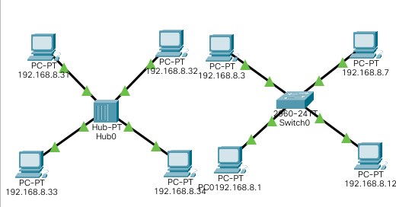
2. IP address configuration:
- Click on the PC whose IP is to be configured.
- The desktop panel would be opened.
- In the static Menu there is an option of IP configuration. Enter the IP address with which the PC is to be configured as shown in Figure 2.
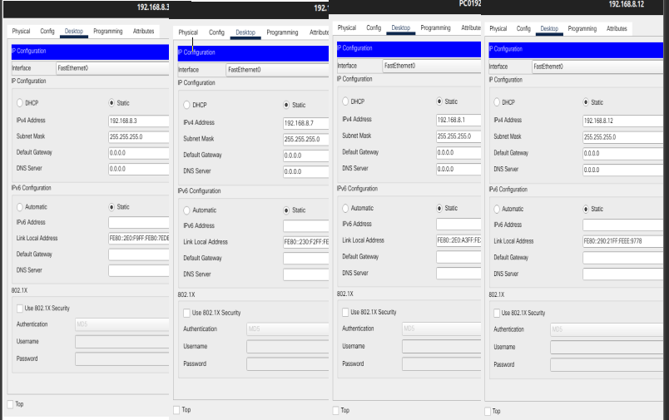
3. Ping testing
- Double click the sender’s PC and go to the desktop menu
- Select the command prompt.
- In the command prompt type the command ping ‘destination IP’. The example of ping command is shown in Figure 3
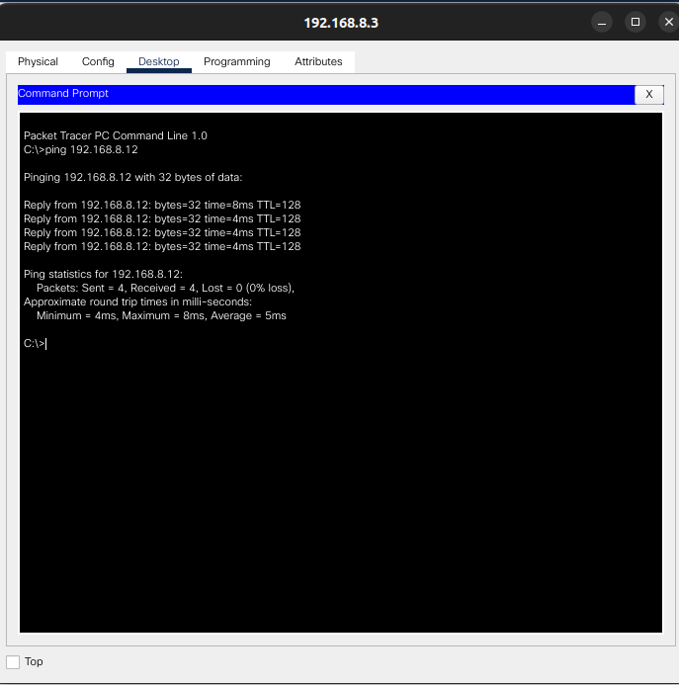
4. Real Mode simulation
- Click and drag the message icon to one of the PC’s who is acting as a sender & click on it, after that click on the receiver PC.
- Click the event Simulation mode which is on the right side of the panel, a panel will appear.
- On that panel bottom right corner there will be a button of capture and forward. Press it to start the simulation & record the states after each press as shown in Figure 4.
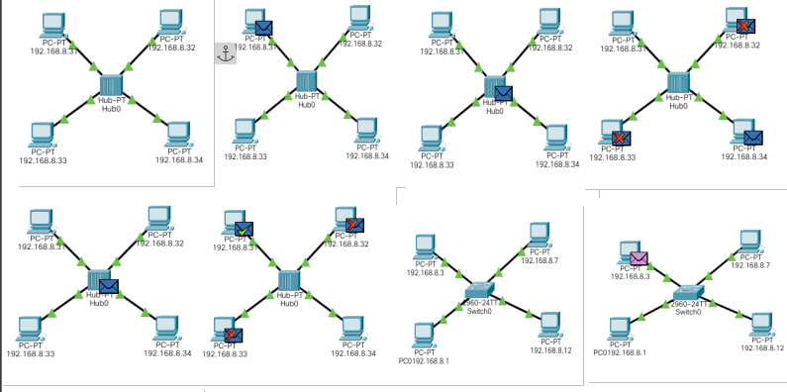
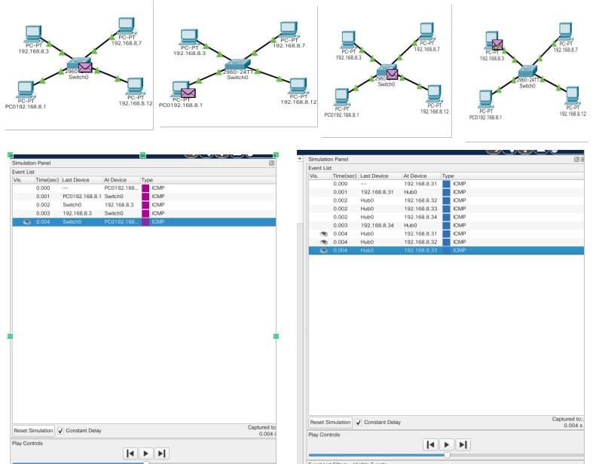

5. Advantages of Star Topology:
- Easy to manage.
- Easy to locate.
- Easy to expand than a bus or ring topology.
- Easy to install and wire.
Disadvantages of Star Topology:
- Requires more cable length than a linear topology.
- If central device fails, entire network fails.
6. Comparison between HUB and SWITCH:
I. HUB:
- Hubs broadcast data to all the network devices.
- It shares total bandwidth among all connected devices.
- It creates a single collision domain for all devices.

II. SWITCH:
- It manages data traffic by sending data only to destination.
- Switch provide dedicated bandwidth to each port preventing network shutdown.
- It creates separate collision domains. Thus, reducing collision.

Q2 Design Bus Topology using Switch and demonstrate its behavior in real time simulation Mode. State Advantages & Disadvantages of Bus Topology.

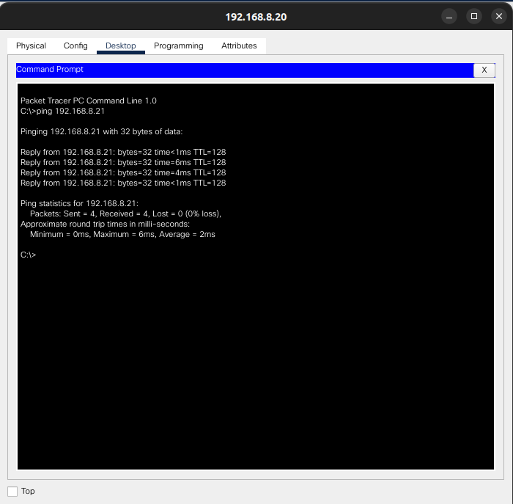

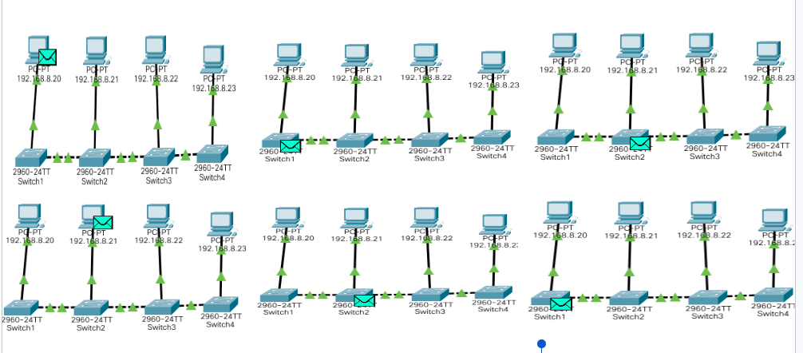

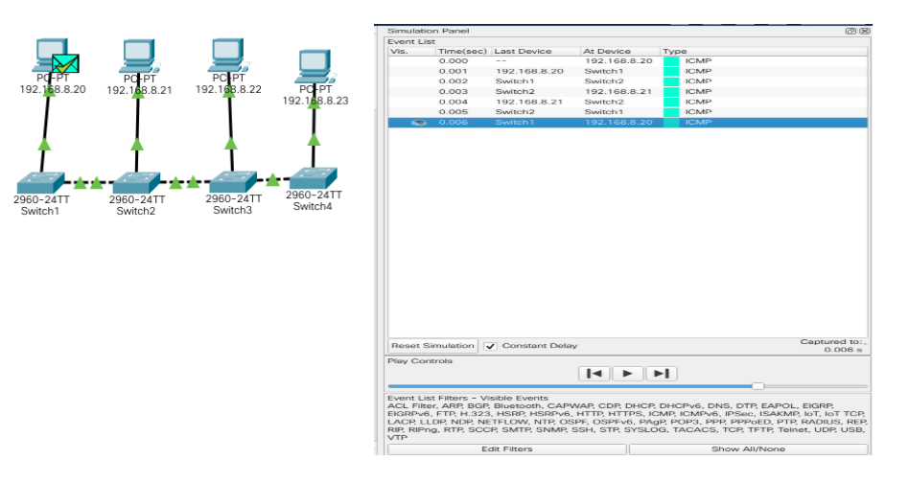

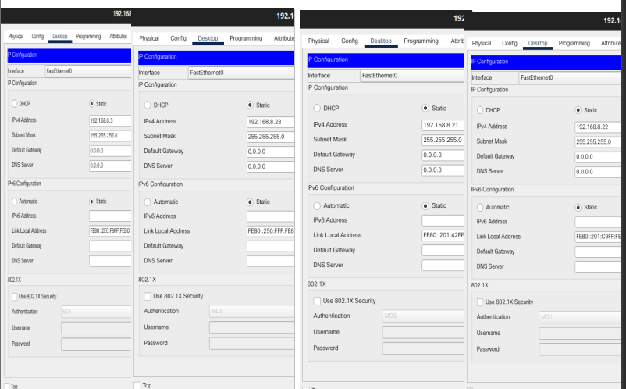
Q3 Design Ring Topology using Switch and demonstrate its behavior in real time simulation Mode. State Advantages & Disadvantages of Ring Topology.
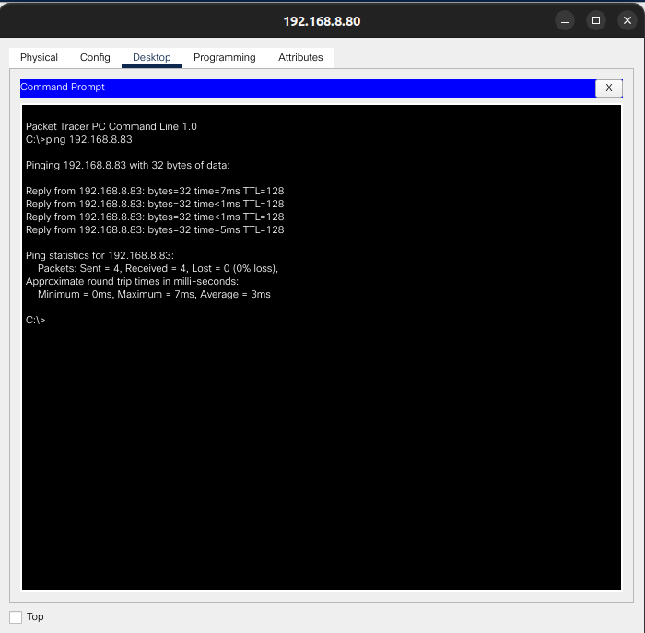

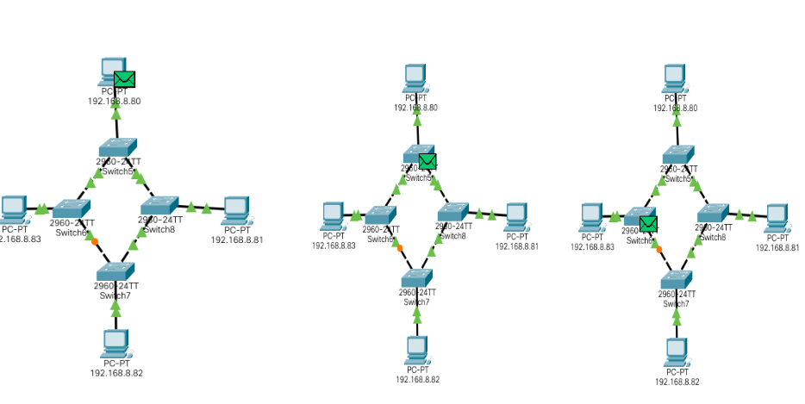
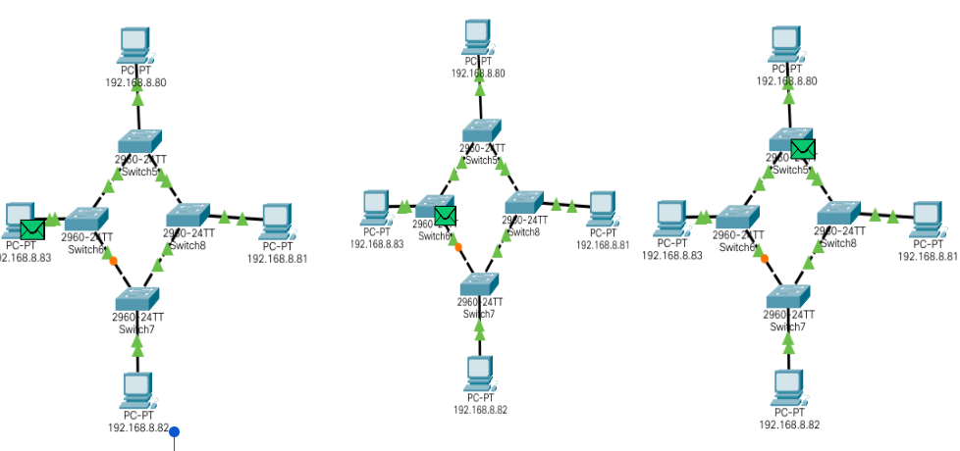
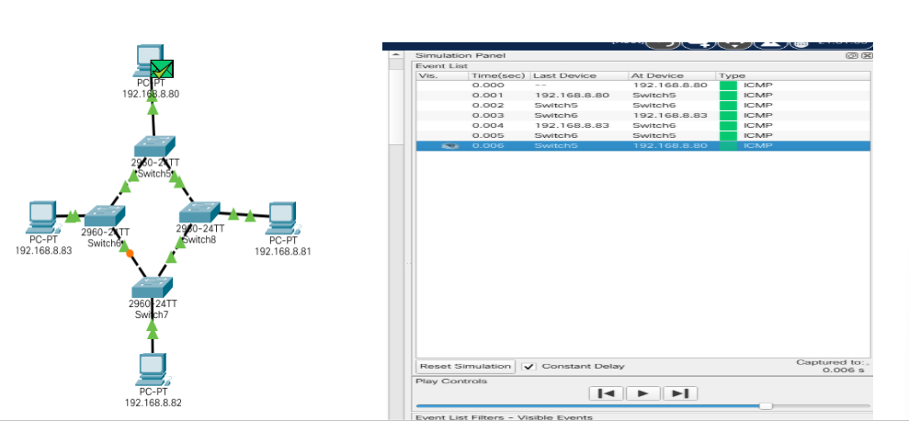

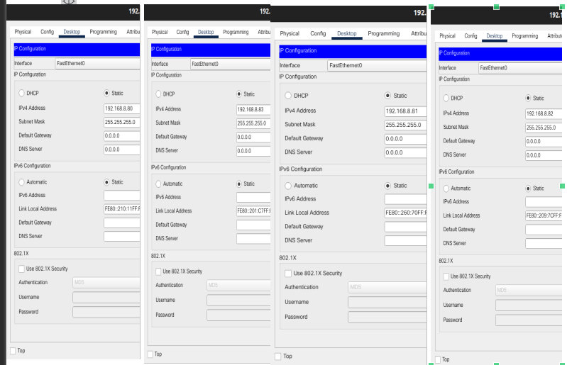

Q4 Design Mesh Topology using Switch and demonstrate its behavior in real time simulation Mode. State Advantages & Disadvantages of Mesh Topology.
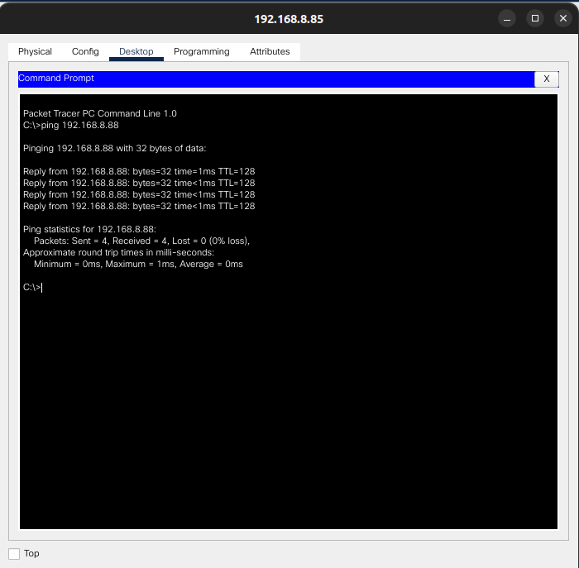

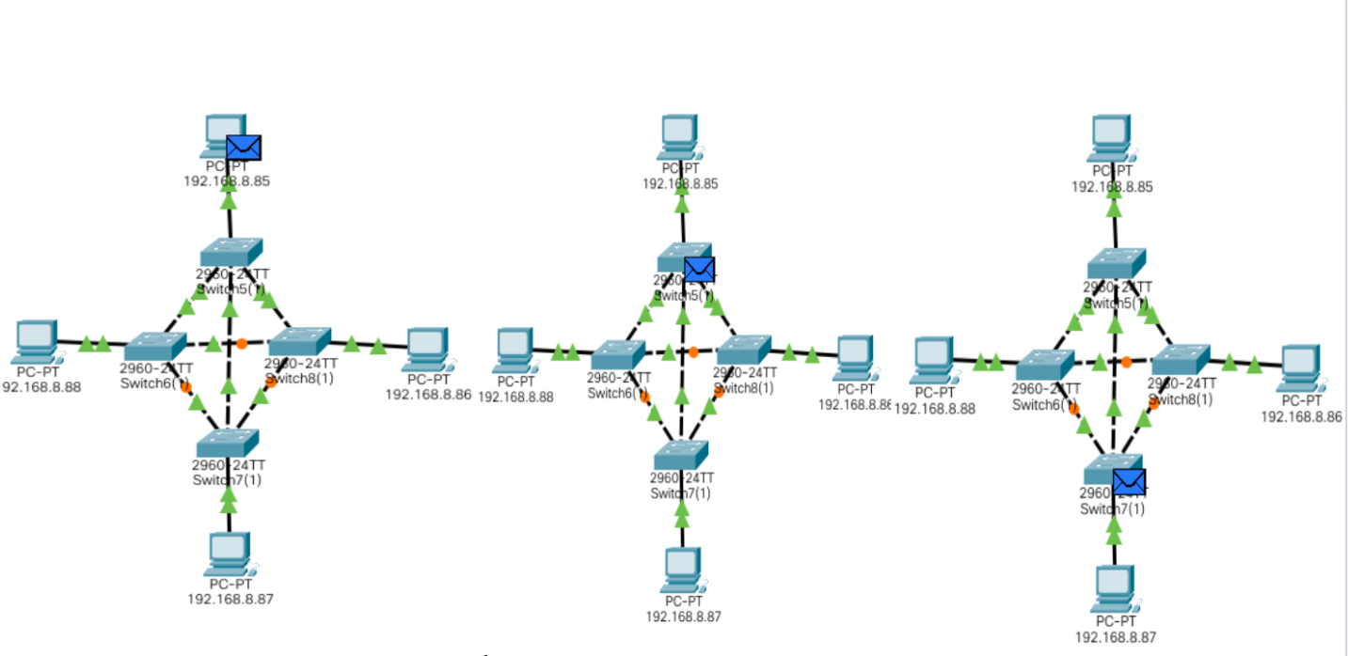

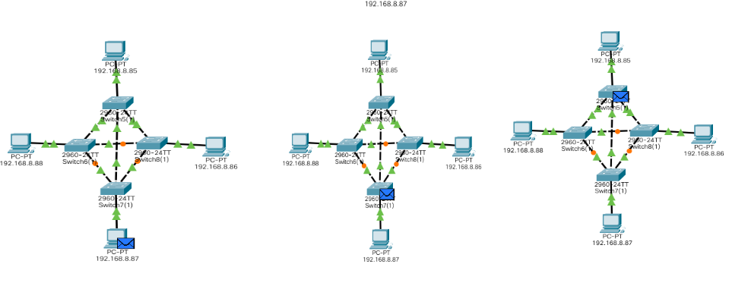
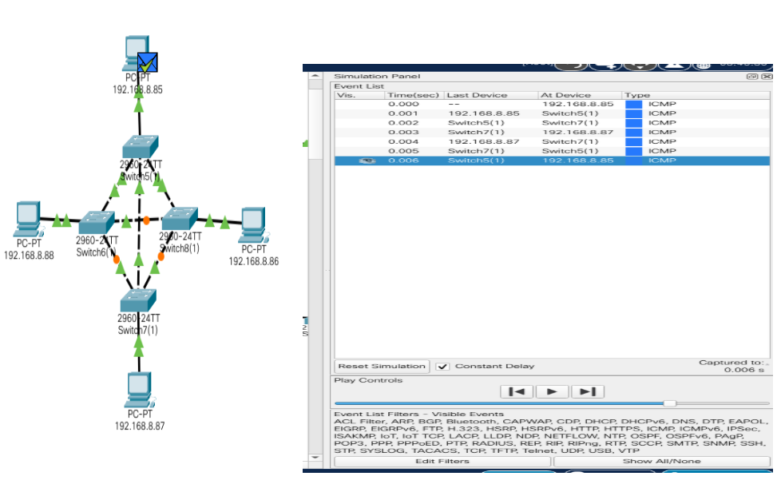
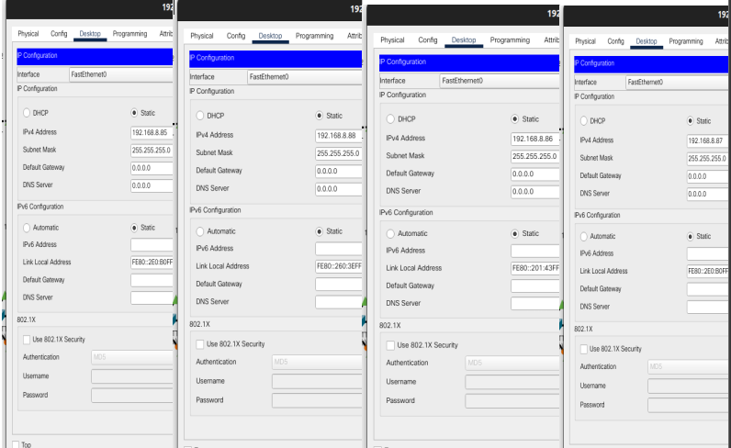

Q5 Design Hybrid Topology using Switch and demonstrate its behavior in real time simulation Mode.

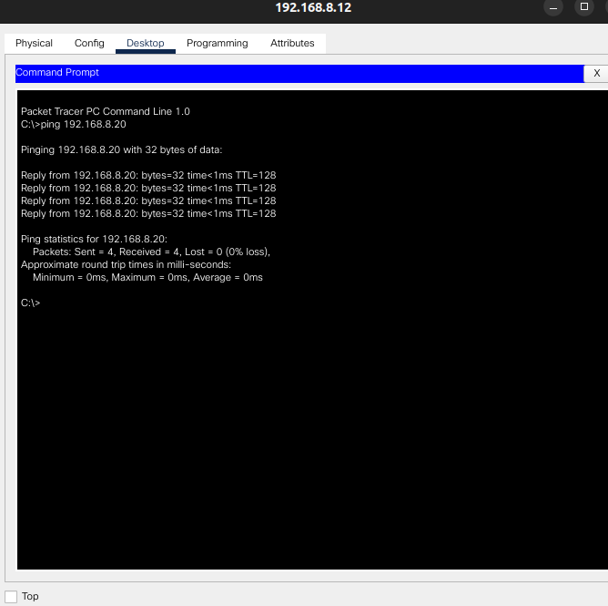

Conclusion
The experiment successfully demonstrated various network topologies and transmission media using Cisco Packet Tracer. The configurations helped in understanding network design, device connectivity, and data communication using different cable types and topological structures.

FAQs
S. No. | Question | BT Level | Cognitive Level
 | Why Topology is Important? | Understand (L2) | Comprehension
 | What is the purpose of a switch in a star topology? | Understand (L2) | Comprehension
 | What is transmission media in computer networks? | Remember (L1) | Knowledge
 | Name the different types of transmission media. | Remember (L1) | Knowledge
 | Why is optical fiber preferred over twisted pair cables for long-distance communication? | Understand (L2) | Comprehension
 | Which cable is commonly used to connect a PC to a switch in Cisco Packet Tracer? | Remember (L1) | Knowledge
 | How do you verify network connectivity in Cisco Packet Tracer? | Apply (L3) | Application
 | For AIT Network which topology you will prefer and Why? | Apply (L3) | Application
 | Compare wired and wireless transmission media. | Analyze (L4) | Analysis
 | For each of the following four networks, discuss the consequences if a connection fails.  a. Five devices arranged in a mesh topology  b. Five devices arranged in a star topology (not counting the hub)  c. Five devices arranged in a bus topology  d. Five devices arranged in a ring topology | Apply (L3) | Application

